UDC…

example of materials execution for the international conference «KEY CONCEPTS OF SOIL PHYSICS: DEVELOPMENT, CURRENT APPLICATIONS AND FUTURE PROSPECTS»

Surname F.(irst Name) M.(iddle Name)¹, Surname F.(irst Name) M.(iddle Name)²

¹Faculty of soil science of MSU, Moscow, Russian Federation
Vader@gmail.com
²ISA of SB of RAS, Novosibirsk, Russian Federation
Any@gmail.com

Annotation: Text of annotation, Times New Roman font, 11 pt, normal, alignment – best fit, line spacing - single, left and right indentation – 1 cm. Text size – not more than 50 words.

Main text
Please use this template to execute the materials of the International Conference in Moscow, 2019. The template uses Times New Roman, 13 pt, normal, text alignment - justify, single line spacing, indentation - 1 cm. Text size (with annotation, tables and figures) should not exceed five A4 pages, margins top 2.5 cm, right and left 1.5 cm, bottom 1.5 cm. Subheadings can have two levels (bold and italic) and are written with a capital letter.
The text is recommended to be divided into sections (approximate structure: introduction, objects and methods, results, conclusions, list of references), but such a division is not mandatory. At the end of the text provides information on the financial support of research, before the list of references allowed section "Acknowledgment".

Introduction
Conference materials will be sent to participants and posted in the public domain.

Objects and methods

Second level headings - italic, font size - 13
The text may contain references to the used literature (Hawking, 2000; Ivanov, Petrov, 2001).

Equations
Materials may contain equations typed using Word Equation Editor. No numbering of formulas is allowed.
$$\frac{Δy}{Δx}=\frac{-b±\sqrt{b^{2}-4ac}}{2a}$$
Results and discussion
Section may contain tables and figures. Alignment of figures and tables, figure captions and table headings - in the center. The font size in the titles and cells of the tables and in the captions is 12 pt. Vertical lines are not allowed in the tables.

Table 1. Soil density
Object | Soil density  (g/cm³) | Soil density  (g/cm³) | Soil density  (g/cm³) | Soil density  (g/cm³)
Forest | 1.34 | 1.34 | 1.34 | 1.34
Tilled soil | 1.22 | 1.22 | 1.22 | 1.22
City | 1.42 | 1.42 | 1.42 | 1.42

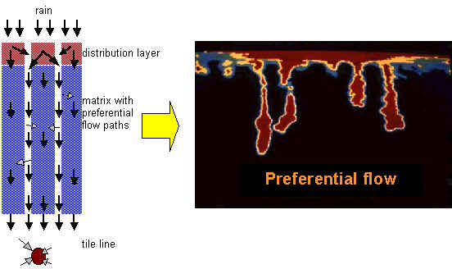
Fig.1. Figures can be colored or black and white.

Conclusions
Conclusions should contain only text. The file with the report materials must be saved in the .docx format. The file name should be given as follows: author's surname and initials in Latin letters. For example, IvanovAA.docx.

Acknowledgment
The work was carried out with the support of the Russian Foundation for Basic Research (projects no. Xx-xx-xxxx, xx-xx-xxxx).

References
Author А.A. (2011) Number of ………..ure. Journal of …... Science 109, 447-461.www.regional.org.au/au/asa/2001/5/a/johnson.htm.

