Direct Lithium Extraction Technology via Selective MOF Membrane
Doroshenko I.V. ¹, Moshkova M.A. ¹, Gattabria C. ¹, Krivoshapkina E.F. ¹
1st year PhD student
¹ITMO university, Advanced engineering school PISH, St. Petersburg, Russia
E-mail: doroshenko@pish.itmo.ru
Introduction. Lithium, a critical component in most electronic devices, is currently facing a surging global demand that outpaces traditional supply chains. This escalating scarcity threatens to hinder technological advancement and push the cost of electric vehicles and high-tech electronics up to luxury levels [1, 2]. Therefore, innovative lithium sourcing strategies are imperative, with the direct extraction of lithium from brines emerging as a viable solution, particularly – from not used earlier sources of oil and gas condensate fields wastewaters [3].
Body part of the report summary. The research proposes a direct lithium extraction approach based on the polymer membrane modified by metal-organic frameworks (MOFs).
Membranes after 1–10 MOF modification cycles were prepared and characterised by a combination of Fourier transform infrared spectroscopy, scanning electron microscopy, and energy-dispersive X-ray spectroscopy. While initially it was expected that increasing the number of modification cycles would improve the uniformity of the MOF layer, ultimately the optimal number of cycles had to be determined based on the results of electrochemical tests. Specifically, the reduced lithium selectivity at low cycle numbers was attributed to the incomplete and non-uniform MOF coverage. Conversely, excessive modification also led to a decrease in selectivity, likely due to surface defects and regions with disrupted MOF coating.
In addition to the investigation of MOF membrane properties and the subsequent optimisation of the modification, this study provides an integrated assessment of the workflow for lithium extraction from oilfield brine. The process encompasses brine pre-treatment, systematic evaluation of membrane separation parameters, and a final lithium carbonation stage. Using this workflow, lithium carbonate with a purity of up to 98.44% is obtained from an East Siberian oilfield brine sample (Fig. 1).
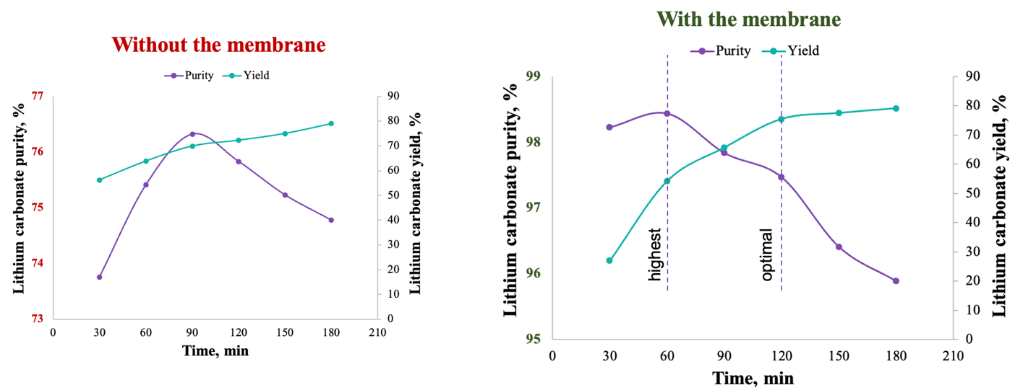
Fig. 1. Lithium carbonate purity comparison
Conclusions. The research findings confirm the efficiency of the proposed technology and highlight its strong potential for further validation at an industrial scale.
This work was supported by the Ministry of Science and Higher Education of the Russian Federation (Project FSER-2025-0016).
References
1. Moshkova M.A. et al. From technology to economy: An evaluation of engineering in direct Lithium extraction // Desalination. 2025. Vol. 616.
2. I. Energy Agency, The Role of Critical World Energy Outlook Special Report Minerals in Clean Energy Transitions.
3. Yu H. et al., “Selective lithium extraction from diluted binary solutions using
MOF-based membrane capacitive deionization,” Desalination, vol. 556, p. 116569, Jun. 2023.

