Prediction of thiacalix[4]crown-ethers aggregate morphology with feature selection guided Machine Learning algorithms
Makarova T.A., Ireddy A.T.S., Botnar A.A., Chetinel I.D., Zun P.S., Muraveva E.A., Skorb E.V., Muravev A.A.
Student, 1st year of Master's degree
Infochemistry Scientific Center, ITMO University, St. Petersburg, Russia
E-mail: makarova_taisiya@niuitmo.ru
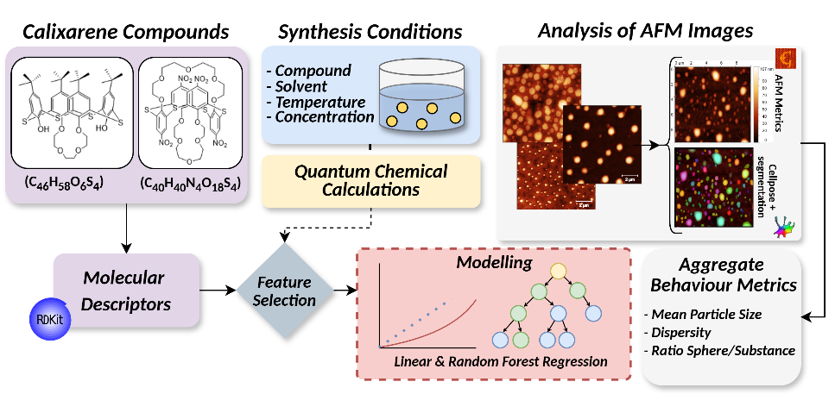
Amphiphilic tert-butylthiacalix[4]monocrown-4-ether and bolaamphiphilic nitrothiacalix[4]biscrown-5-ether belong to the class of thiacalix[4]crown-ether compounds are potentially useful for analyte binding in biomedical, nanoelectronic and environmental applications. Calixarene films were formed on quartz substrates under varying experimental conditions of temperature (4℃, 23℃), compound concentrations (10⁻⁴, 10⁻⁵ mol/L) and solvents (toluene and chloroform) [1]. Using atomic force microscopy (AFM), detailed scans of the film surfaces reveal existence of spherical aggregates. We analyze the films to characterize aggregate behavior via three descriptive metrics: mean particle size, dispersity (ϼ) (the heterogeneity of aggregate size) and ratio of substrate-substance on the films (area of aggregated covered surface). Acquired AFM images of calixarene films were segmented to extract descriptive metrics using Cellpose+ [2]. Using machine learning (ML) algorithms we build a predictive model with experimental synthesis data, molecular descriptors and quantum mechanical properties. Our work presents a structured pipeline to predict aggregate morphology with feature-selection-guided machine-learning algorithms by introducing an algorithm to craft set(s) of predictors consisting of three groups of data exclusively, i.e. (a) experimental synthesis conditions and results of quantum mechanical calculations (e.g. molecular packing factor, hydrophilicity etc.) [1]; (b) molecular descriptors of calixarene compounds and solvents calculated using RDKit toolkit [3]; (c) a combination of (a) and (b); (2) perform comprehensive feature selection using T-test, Correlation Feature Selection, Mutual Information Function (MIF), and Separability of Split Value to identify the most significant experimental and molecular characteristics during modelling; (3) Implement Linear Regression (LR) and Random Forest (RF) algorithms to predict descriptive aggregate metrics.
Fig. 1. Modeling pipeline for prediction of target descriptive aggregate metrics
Our observer the most significant features to be synthesis conditions (temperature of compound and solvent), topological surface area, descriptors from Van der Waals Surface Area group, structural groups (fr_phenol, NHOHCount etc.), which are closely linked with molecular sphericity. The best performance was observed with LR using T-test and MIF for feature selection and predictors from dataset (a), i.e. temperature of compound, hydrophilicity, packing factor, which represent molecular behavior of calixarenes and therefore their aggregation.
References
1. Chetinel I. D. et al. Control of self-organization of thiacalix[4]crown-ethers in cone and 1, 3-alternate forms in nanofilms on quartz substrate //Colloid Journal. 2025. Vol. 87. P. 236-245.
2. Huaman I. A. et al. Cellpose+, a morphological analysis tool for feature extraction of stained cell images //Advanced Intelligent Discovery. 2026. Vol. 2. P. 202500005.
3. Landrum G. et al. rdkit/rdkit: 2024_09_1 (Q3 2024) Release Beta //zenodo. – 2024.

