Coherence and Metacommunity Structure of Testate Amoebae on Yakushima Island, Japan
Zhu Qihan
Postgraduate student,2nd year of study
Shenzhen MSU-BIT University,
Faculty of Biology, Shenzhen, China
E-mail: 3120230021@smbu.edu.cn
Revealing the most prevalent community pattern is one of the central issues in community ecology. The study of protist communities, a vital component of terrestrial ecosystems, offers valuable insights into community dynamics. However, many previous studies of this group provided inconsistent results. In this study on the subtropical Yakushima Island, Japan, following a comprehensive framework, we investigate the Elements of Metacommunity Structure (EMS) (Leibold & Mikkelson, 2002; Presley et al., 2010) to determine the pattern that best describes the metacommunity of testate amoebae, a group of ecologically important free-living protists, and seek to relate the structure to the responsible mechanisms.
The Principal Component Analysis (PCA) suggested a heterogeneity among sites (Fig. 1), confirmed by PERMANOVA, with a p-value of 0.008.

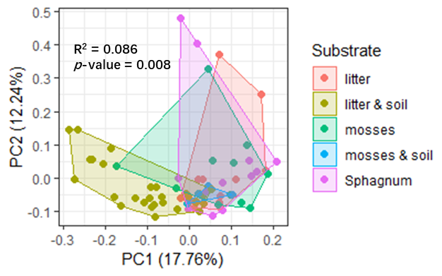
Fig. 1. PCA ordination plot (site scores) and the result of PERMANOVA test

Consequently, the “fixed-fixed” null model was chosen to generate randomly expected metacommunities. Coherence, the first EMS to be investigated, refers to the extent to which species in a metacommunity respond to the same gradient (Leibold & Mikkelson, 2002; Presley et al., 2010). This element is represented by the total number of embedded absences, the absences of each species interrupting the species’ range (the array of sites where it occurs) in a re-ordered incidence matrix using reciprocal averaging (Leibold & Mikkelson, 2002; Presley et al., 2010). The less embedded absences, the higher the coherence (Leibold & Mikkelson, 2002; Presley et al., 2010). The observed number of embedded absences was compared with those expected by chance. The results are in Table. 1. The observation was significantly lower than expected by chance, suggesting significantly high coherence (Presley et al., 2010).

Observed Embedded Absences | z | p | Simulated Mean | Simulated Variance
4.593 × 10³ | -8.17 | < 0.001 | 5.369 × 10³ | 1.620

Table.1. Results of the investigation on metacommunity coherence

Further perspectives of this study are related to the analysis of other EMS.

References
1. Leibold M.A., Mikkelson G.M. Coherence, species turnover, and boundary clumping: Elements of meta‐community structure // Oikos. 2002. Т. 97. № 2. С. 237–250.
2. Presley S.J., Higgins C.L., Willig M.R. A comprehensive framework for the evaluation of Metacommunity Structure // Oikos. 2010. Т. 119. № 6. С. 908–917.

