Spatial and species distribution of bivalve mollusks on the Southeastern and Southwestern Kamchatka shelf based on the expedition
"Pacific Floating University 2024"
Sidorenko F.A.¹, Alaverdov E.S.², Konovalov D.S.³, Chichenko V.A.², Podoba A.V.⁴, Keremsheva E.V.²
Student, 2nd-year undergraduate
¹Shenzhen MSU-BIT University, Shenzhen, China,
²Far Eastern Federal University, Vladivostok, Russia,
³ Northern Water Problems Institute, Karelian Research Centre of the Russian Academy of Sciences, Petrozavodsk, Russia,
⁴Far Eastern State Technical Fisheries University, Vladivostok, Russia
E-mail: fedor.s14062017@gmail.com
Introduction: bivalve mollusks are crucial macrobenthic organisms, indicative of environmental changes due to their sedentary nature and extended lifecycles [1]. Despite their ecological importance, targeted studies on their spatial distribution along Kamchatka's shelf were lacking. This study aims to fill this gap.
Materials and Methods: Samples were collected with a box-corer (0.1 m²) during the "Pacific Floating University 2024" expedition aboard the RV "Professor Multanovsky". Samples were washed through sieves (mesh sizes 1–20 mm), fixed in 4 % formalin and identified using standard identification atlases and guides [2]. Quantitative data were recalculated per m². Oceanographic parameters were measured using a CTD 48M probe (Sea&Sun, Germany).
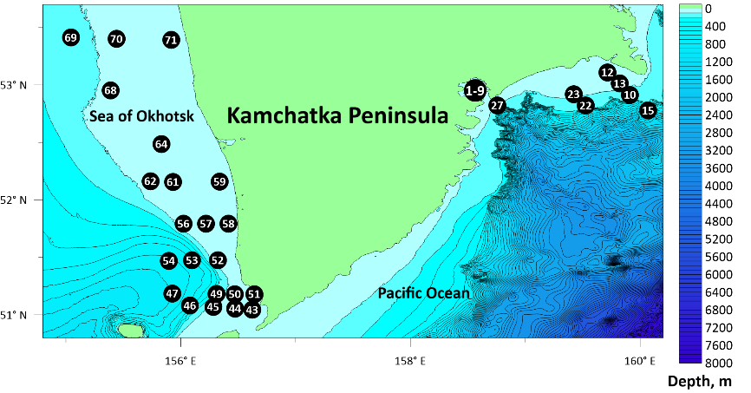
Fig. 1. Stations with bivalve mollusk findings, Kamchatka coastal waters
Results: Bivalves were identified at 54 % (38 of 70) of stations (Fig. 1), with 17 species from 11 families documented. Macoma calcarea numerically dominated (94.36 % in Avacha Bay). Maximum diversity (7 taxa) was observed at station №10 (135 m depth). Southwestern Kamchatka featured dominance by Macoma calcarea in the south, while northern stations were dominated by Ennucula tenuis and Astarte borealis. Potential freshwater influence was noted, with no clear correlation found with depth or temperature. Thyasiridae family representatives, provisionally identified as Parathyasira equalis and Axinopsida subquadrata, require genetic identification, with additional samples planned for the next expedition.
Conclusions: Macoma calcarea shows significant ecological adaptability and dominance across various habitats. The presence of Arctic species in the northern shelf areas necessitates further research. The study provides vital data for ecological monitoring and understanding benthic community dynamics.
The authors express their gratitude to Rutenko O.A. for scientific guidance and leadership of the expedition, and to Konik A.A. and Atadzhanova O.A. for providing hydrophysical data.
References
1. Nadtochiy V.A., Budnikova L.L., Bezrukov R.G. Some results of benthos assessment in Russian waters of the Far Eastern Seas: Composition and quantitative distribution (Sea of Okhotsk) // Izvestiya TINRO. 2007. Vol. 149. P. 310–328.
2. Yavnov S.V., Pozdnyakov S.E. Atlas of Bivalve Mollusks of the Russian Far Eastern Seas. // Vladivostok: Publishing House "Duma". 2000. P. 168.

