Influence of silver nanoparticles and silver ions on the fluorescence of aromatic amino acids by quenching mechanism.
Smirnov.V.A.¹, Shank M.A.^{1,2}, Demidov.N.M.^{1,2}, Oneshko V.¹, Pirutin S.K.^{1,2}
Student, 3rd year of bachelor’s degree
¹ MSU-BIT University in Shenzhen
² Lomonosov Moscow State University
E-mail: smirnov.va@do-student.ru
Silver nanoparticles (AgNPs), commonly used in nanomedicine and cosmetics, require safety assessments due to their interactions with biomolecules. This study examines how AgNPs and silver ions (AgNO₃) modify the fluorescence of aromatic amino acids (tryptophan, tyrosine, phenylalanine), critical for protein structure/function. Observed fluorescence changes reveal molecular interactions, highlighting the need to understand these mechanisms, as knowledge gaps may pose unforeseen risks in biomedical and consumer applications.
The objects of research were solutions of L-tryptophan (150 μM), L-tyrosine (1 mM), and L-phenylalanine (5 mM) in PBS (pH 7.4). Fluorescence spectra were recorded using a Lumina Fluorescence Spectrometer (Thermo Scientific). Excitation wavelengths were 280 nm (Trp) and 260 nm (Tyr, Phe). The effects of AgNPs and AgNO₃ were tested at concentrations of 10–150 μM. Data analysis employed the Stern-Volmer equation to evaluate quenching constants (K) and interaction mechanisms.
The results show that AgNPs and AgNO₃ reduced fluorescence of Trp, Tyr, and Phe. At 150 μM, AgNPs cut tryptophan fluorescence by around 40% and AgNO₃ by 35% (quenching constants: 0.00198 (AgNPs), 0.00185 (AgNO₃)), both via complex formation, with Trp possibly reducing Ag⁺ [1, 2] or Tyr at 100 μM, AgNO₃ reduced it by 60%, AgNPs by 45% (constants: 0.00345 (AgNO₃), 0.0017 (AgNPs)), with AgNO₃ complexing strongly and AgNPs adsorbing weakly [2, 3]. AgNO₃ fully quenched Phe at 50–100 μM possibly via oxidation, while AgNPs had a weak effect (constant 0.01167) [2, 4].
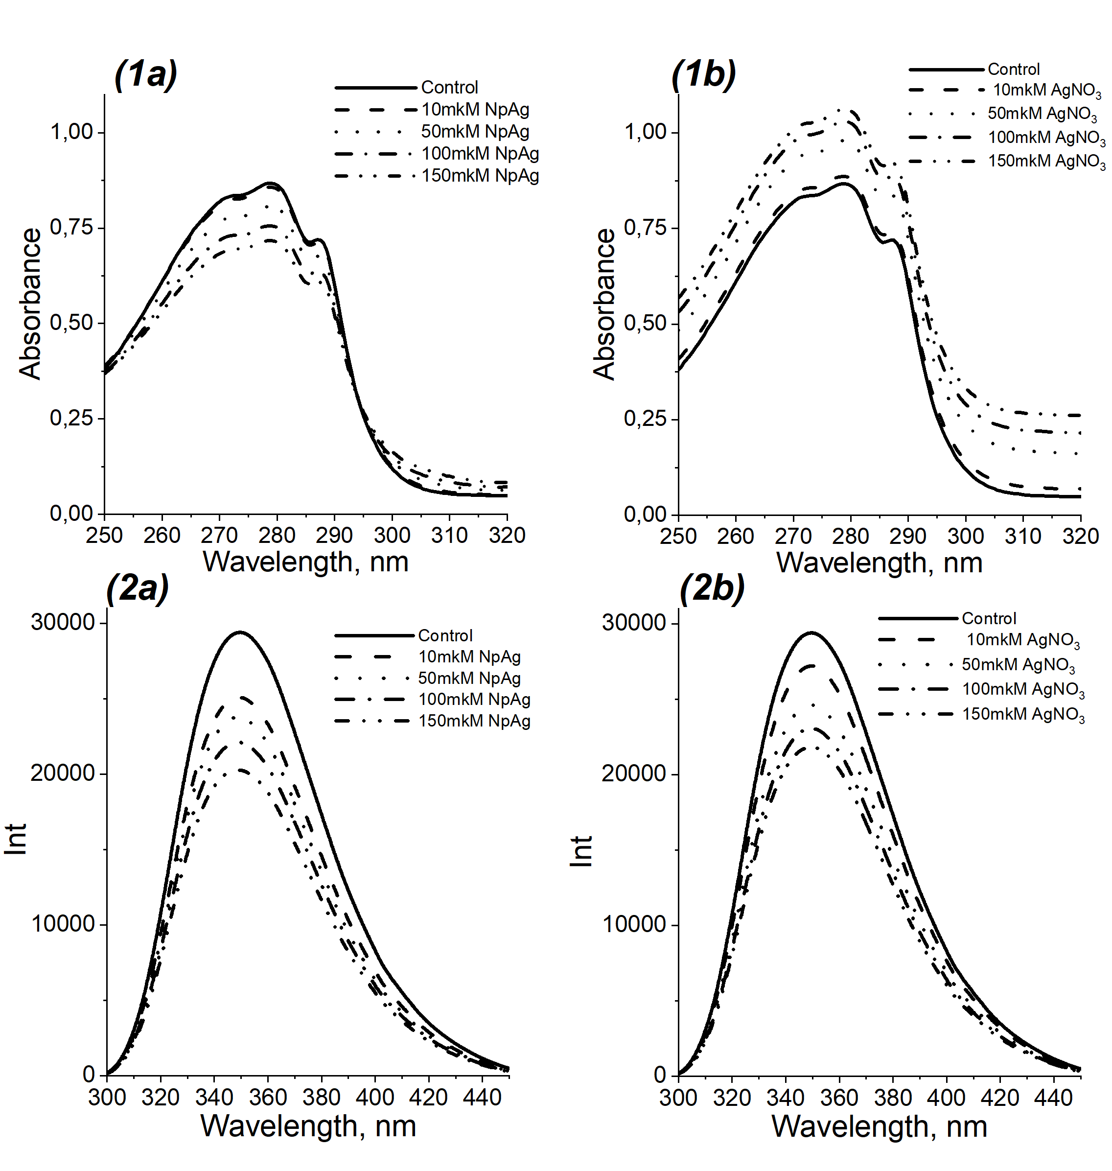 | 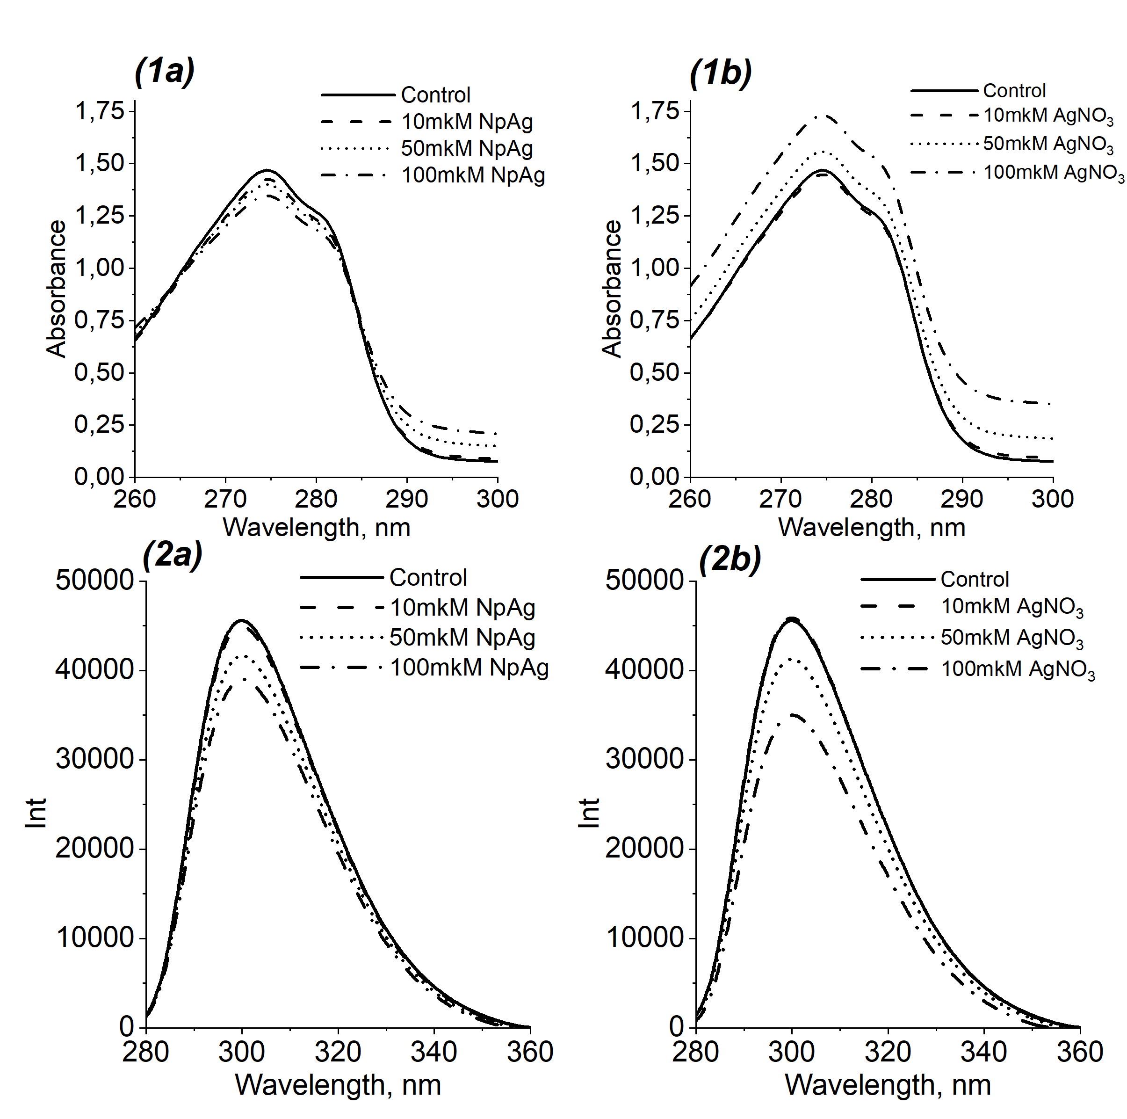
a | b | c

Figure 1: (1) – Absorption spectra (2) – Fluorescence spectra of 150mkM (a)Trp (b) Tyr (c) Phe with (1a) NpAg and (1b) AgNO3 with 10, 50, 100 and 150 mkM.
AgNPs and AgNO₃ quench Trp similarly through complex formation. Tyr shows stronger quenching with AgNO₃, suggesting Ag⁺ coordination. Phe is completely quenched by AgNO₃ due to oxidation, while AgNPs have little effect. This indicates Ag⁺ poses greater oxidative risks to tyrosine and phenylalanine than AgNPs. AgNPs, common in nanomedicine and cosmetics, need safety checks. This study tests how AgNPs and AgNO₃ alter fluorescence in key amino acids - Try, Tyr, Phe, showing molecular interactions and risks from poor understanding. This study shows that further deeper research will be required.
References
1. Iravani, S., & Badiei, R. (2010). Preparation of silver nanoparticles using tryptophan and its formation mechanism. Colloids and Surfaces B: Biointerfaces, 79(2), 414–419.
2. Hormozi-Nezhad, M. R., et al. (2015). Study of interaction between tryptophan, tyrosine, and phenylalanine separately with silver nanoparticles by fluorescence quenching method. Journal of Applied Spectroscopy, 82(5), 755–761.
3. Lakowicz, J. R. (2006). Principles of Fluorescence Spectroscopy (3rd ed.). Springer
4. Naik, R. R., et al. (2002). Biomimetic synthesis and patterning of silver nanoparticles. Nature Materials, 1(3), 169–172.

