Enhancing Parkinson's Disease Diagnosis Through Integrated Multi-Modal Analysis
Xiaoyan Zhou¹, Renfei Ma²
Student, 2nd year of specialist (master's)
^{1,2}Shenzhen MSU-BIT University,
Faculty of Biology, Shenzhen, China
E-mail: 2120230130@smbu.edu.cn
Parkinson’s disease (PD) is a complex and progressive neurodegenerative disorder characterized by high heterogeneity, making early diagnosis challenging [1]. Early detection and intervention are critical for slowing disease progression, necessitating a deeper understanding of PD’s diverse biological mechanisms. Advances in noninvasive imaging and multi-omics technologies have provided valuable insights into PD’s underlying causes, but integrating these diverse data sources remains a significant challenge, particularly in extracting meaningful diagnostic features. This study introduces a novel integrative, multimodal predictive model for PD detection, leveraging data from the Parkinson’s Progression Markers Initiative. The model incorporates features derived from hematology, proteomics, RNA sequencing, metabolomics, and dopamine transporter scan imaging. Multiple model architectures were explored, including support vector machines, eXtreme Gradient Boosting, fully connected neural networks with concatenation (FCNN_C) and joint modeling (FCNN_JM), and a multimodal encoder-based model with multi-head cross-attention (MMT_CA). Among these, the MMT_CA model demonstrated the highest predictive performance, achieving a balanced classification accuracy of 97.7%, effectively capturing cross-modality dependencies to enhance prediction accuracy.
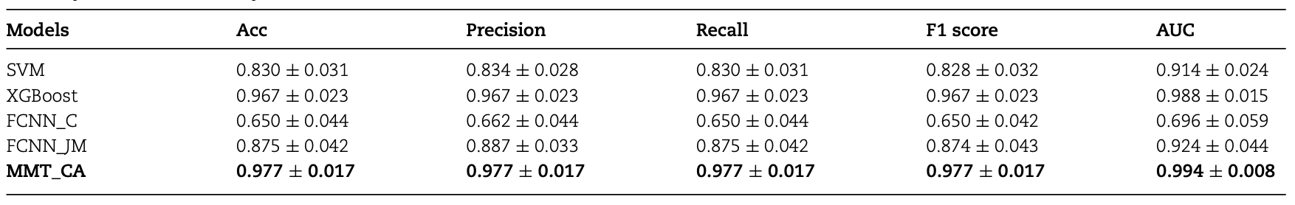
Figure 1. Comparison of mean predictive performance across different model architectures using accuracy, weighted average precision, recall, F1 score, and ROC-AUC.
Additionally, feature importance analysis using SHapley Additive exPlanations (SHAP) identified key diagnostic biomarkers that informed model development and hold promise for future research. These findings contribute to a multi-omics perspective on PD, supporting precision medicine approaches aimed at identifying therapeutic targets and slowing disease progression.
Literature
1. Váradi C. Clinical features of Parkinson’s disease: the evolution of critical symptoms. Biology 2020; 9:103. https://doi.org/10.3390/biology9050103

