Influence of the surface-oriented polymer structure on the neuroblastoma cell differentiation
Diana Meskhadze¹
Student, 2nd year master’s degree
¹Shenzhen MSU-BIT University, Faculty of biology, Shenzhen, China
E-mail: diana150701@mail.ru
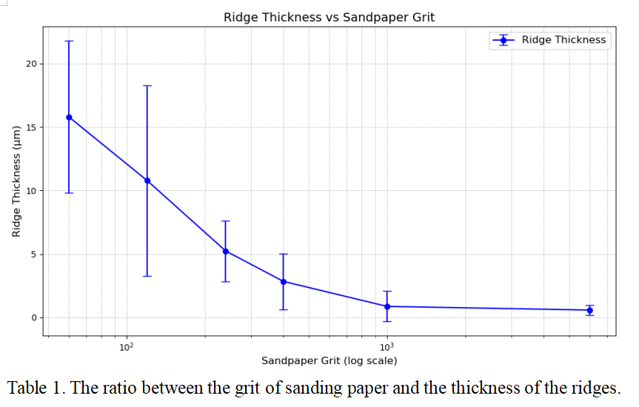
The influence of the surface on the differentiation of neuroblastoma cells is an area of research that explores how the properties of the substrate on which neuroblastoma cells are cultured affect their differentiation status. This study explores how different surface characteristics impact the morphological and functional differentiation of neuroblastoma cells, particularly focusing on the SH-SY5Y cell line. The human-derived SH-SY5Y cell line is a simple and inexpensive in vitro experimental neuron-like model for studying microenvironment influences. Recent research highlights the role of surface topography and chemical composition in guiding the differentiation process. So, stretching and changing shape is an indicator, that means the metabolism in the cell has also changed. Studies have shown that specific topographical cues can induce neuronal differentiation or inhibit cell proliferation by mimicking the microenvironment of neural tissues. By maintaining specific surface characteristics and culture conditions, researchers can achieve stable cell populations that exhibit reliable differentiation patterns over extended periods. This stability is crucial for studying neurodevelopmental processes.[1]
Figure 1. The ration between the grit of sanding paper and the thickness of the ridges.
Films with different topographies were obtained for growing cells. Films were made with 4 % PHB (Poly(3-hydroxybutyrate))[2] solution in chloroform, placed on a slip glass with ridges, made with sandpaper grit of 60, 120, 240, 400, 1000 and 6000, followed by air-drying for 1 day. In the Figure 1 we visualize the results of measuring the thickness of the ridges and the sandpaper grid that was used. The air-dried PHB solid films were taken out, cut into small pieces and put into 24-well plate. SH-SY5Y cells were added into 24-well plate (about 2000 cells per well), and incubated for 7 days. The observations indicate that neuroblastoma cells successfully attach to the polymer, with surface topography influencing the direction of cell elongation. This behavior suggests a link to neuronal polarity, as cells respond to topographical cues from the substrate. Initial visual analysis supports this relationship, and further investigation will focus on identifying correlations between ridge thickness and elongation direction.
Optimizing surface properties such as roughness, chemical composition, and mechanical characteristics can significantly enhance neuronal differentiation, providing a robust platform for neurobiological research and investigating the influence of the surface on neuroblastoma cell differentiation is essential for gaining insights into the tumor microenvironment, identifying potential therapeutic targets and for studying Alzheimer's and Parkinson’s diseases .
References
- Shipley MM, Mangold CA, Szpara ML. Differentiation of the SH-SY5Y Human Neuroblastoma Cell Line, 2016. doi: 10.3791/53193.
- Bonartsev AP, et al. Biosynthesis of poly(3-hydroxybutyrate) copolymers by Azotobacter chroococcum 7B: A precursor feeding strategy. Prep Biochem Biotechnol. 2017 Feb 7;47(2):173-184. doi: 10.1080/10826068.2016.1188317.

