A Transfer Learning Approach for Predicting Kinase-Specific Phosphorylation Sites of Understudied Kinases
Huang Wentao¹, Ma Renfei¹
2nd year Master's student
¹Shenzhen MSU-BIT University,
Faculty of biology, Shenzhen, China
E-mail: 2120230111@smbu.edu.cn
Phosphorylation is a crucial post-translational modification that plays a pivotal role in cellular signaling and disease mechanisms by regulating protein activities [1]; yet, the identification of specific phosphorylation sites for kinases remains a challenging process that is time-consuming, costly, and human-error prone. Previous studies have introduced kinase-specific phosphorylation site prediction tools, which largely focus on kinases with a sufficient number of experimentally validated phosphorylation sites [2]. However, many kinases remain poorly characterized, either due to limited evidence or unidentified phosphorylation targets, presenting challenges for comprehensive kinase research. This study developed and validated a novel transfer learning-based approach for predicting specific phosphorylation sites in understudied kinases. By leveraging pre-trained models at the respective kinase group levels, custom models have been developed through fine-tuning on layers of closely related kinases. Notably, the encoding of substrate-specific site locations is utilized as critical features within the predictive model. The proposed approach demonstrates balanced accuracies of 78.3 %, 81.9 %, and 83.7 % for 18, 17, and 13 understudied kinases across the Other, STE, and TKL groups, respectively. This study provides robust tools for understanding phosphorylation in understudied kinases, contributing to therapeutic development and the broader study of kinase functions.
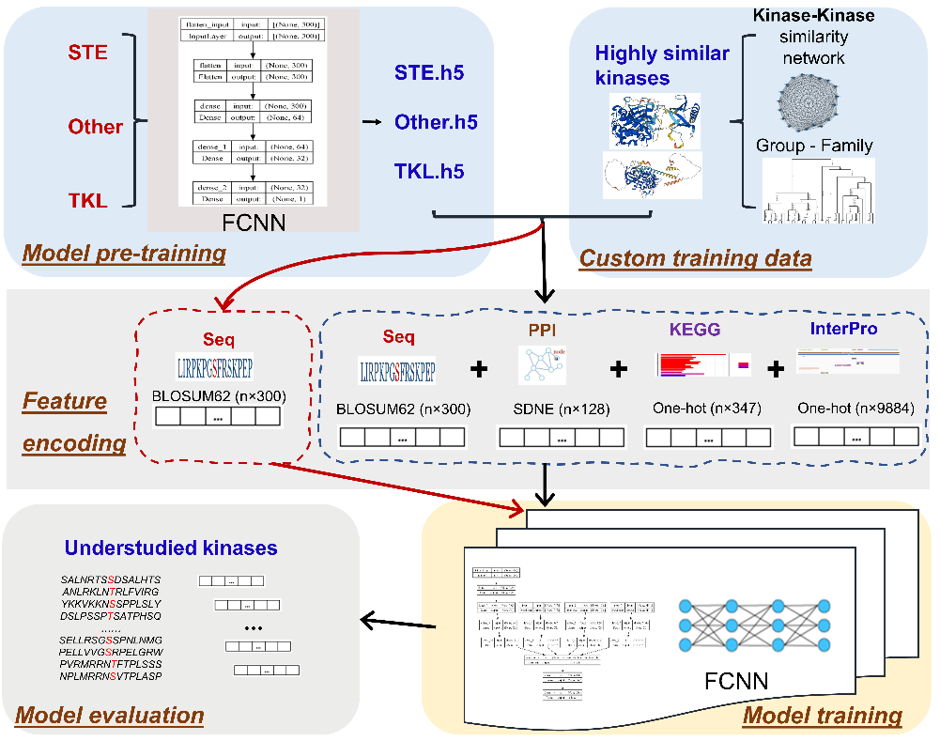
Fig. 1. The schematic of the proposed model
References
1. Pang K., Wang W., Qin J. X., et al. Role of protein phosphorylation in cell signaling, disease, and the intervention therapy // MedComm. 2022. Vol. 3, No. 4. P. e175.
2. Ma R., Li S., Parisi L., et al. Holistic similarity-based prediction of phosphorylation sites for understudied kinases // Brief. Bioinform. 2023. Vol. 24, No. 2. P. bbac624.

