Martini3-Based Coarse-Grained Simulations Reveal Binding Patterns of JAK2 Inhibitors
Gao Yongjun¹, Philipp S Orekhov¹²
2nd year Master student
¹ Shenzhen MSU-BIT University, Faculty of Biology, Shenzhen, China
2 Moscow State University, Department of Bioengineering (Faculty of Biology), Moscow, Russia
E-mail: yongjun.gao@qq.com
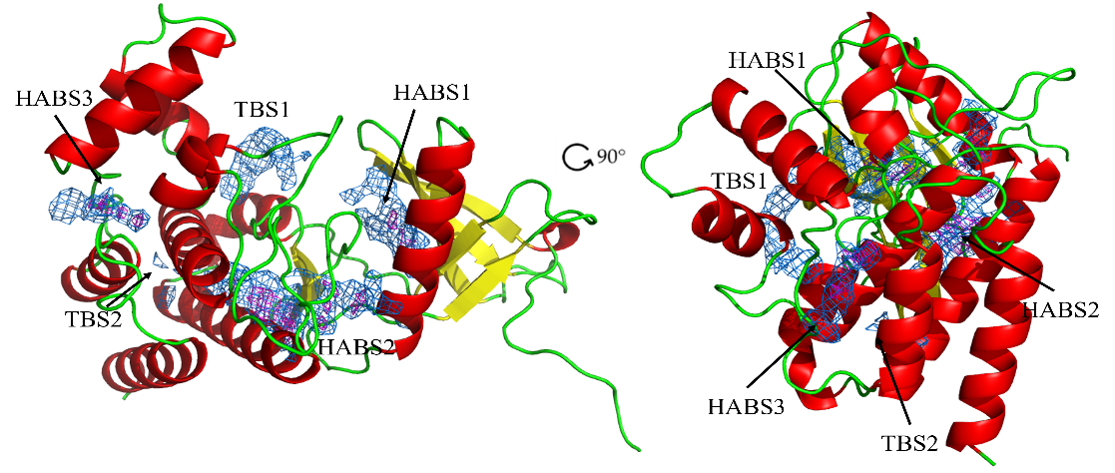
This study investigates the molecular interactions between baricitinib, a JAK2 inhibitor, and the JAK2 protein, utilizing coarse-grained molecular dynamics (CG-MD) simulations with the Martini3 force field [1, 2]. Baricitinib’s role in treating autoimmune diseases underscores the need for a deeper understanding of its binding affinity and stability when interacting with JAK2, particularly in identifying both high-affinity and cryptic binding sites. This research aims to provide novel insights into the protein-ligand interaction dynamics, which are crucial for drug development. By using the Martini3 framework [1], the interaction between baricitinib and the JAK2 JH1 domain (PDB ID: 6VN8) was simulated, allowing for a detailed analysis of binding regions and free energy profiles. The results revealed three high-affinity binding sites (HABS) and two transient binding sites (TBS), highlighting the dynamic nature of the binding process.
Fig. 1. Baricitinib high affinity binding site and cryptic/transient binding site on 6VN8 protein
Free energy calculations demonstrated that binding stability varied across different sites, with some regions exhibiting significantly stronger binding interactions, particularly within 2 Å of the native binding site. Also, another JAK2 inhibitor, CHEMBL4444178, from the ChEMBL database, was examined. This structurally similar compound was found to interact with two high-affinity binding sites and one transient binding site, exhibiting a greater free energy of binding than Baricitinib. This analysis identifies putative binding route of JAK2 inhibitors. Further analyses included a comparison of baricitinib with a decoy compound selected from the DUDE database based on its similar physico-chemical properties to baricitinib but lacking biological activity. Notably, the decoy compound exhibited lower binding affinity to the target protein compared to baricitinib, indicating that the current Martini 3 framework is capable of distinguishing between active compounds and inactive decoy compounds in terms of binding affinity.
References
1. Souza PCT, Thallmair S, Conflitti P, Ramírez-Palacios C, Alessandri R, Raniolo S, Limongelli V, Marrink SJ. Protein-ligand binding with the coarse-grained Martini model. Nat Commun. 2020 Jul 24;11(1):3714. doi: 10.1038/s41467-020-17437-5. PMID: 32709852; PMCID: PMC7382508.
2. Kjølbye LR, Pereira GP, Bartocci A, Pannuzzo M, Albani S, Marchetto A, Jiménez-García B, Martin J, Rossetti G, Cecchini M, Wu S, Monticelli L, Souza PCT. Towards design of drugs and delivery systems with the Martini coarse-grained model. QRB Discov. 2022 Oct 12;3:e19. doi: 10.1017/qrd.2022.16. PMID: 37529288; PMCID: PMC10392664.

