Synthesis of Functionally Substituted Cyclopropane Carboxylic Acids: Design of New Ethylene Biosynthesis Inhibitors and In Silico Investigation of Their Activity
Bagdasaryan S.A.^{1,2}, Grigoryan A.M.^{1,2}, Sahradyan M.G.¹, Mikaelyan A.R.²
Postgraduate student, I year of study
¹Russian-Armenian State University, Yerevan, Armenia
²Armenian National Agrarian University, Yerevan, Armenia
E-mail: sambagd55@gmail.com
Ethylene is an important plant hormone that plays a crucial role in its various physiological processes. It impacts on a broad spectrum of plant growth and developmental stages, encompassing germination, senescence and abscission of leaves and flowers, cell elongation, fruit ripening, nodulation, and the response to a diverse range of stresses [1].
Ethylene is derived from the methionine through a series of reactions [2]. Methionine converts to S-adenosylmethionine, which transforms into 1-aminocyclopropane-1-carboxylic acid (ACC) by ACC synthase. Finally, ACC is converted to ethylene by ACC oxidase (ACO).
Structural analogues of ACC have been proved to have an inhibitory effect on the ethylene production. Our laboratory proposed a technologically easily feasible method of synthesis of functionally substituted ACCs. The generalized scheme includes of ATRA trihaloacetic acid derivatives to unsaturated substrates (terminal olefins) and dehalogenation-cyclopropanation of the resulting 1,3-dihalides with Zn/Cu pair or other metals (Fig. 1) [3].
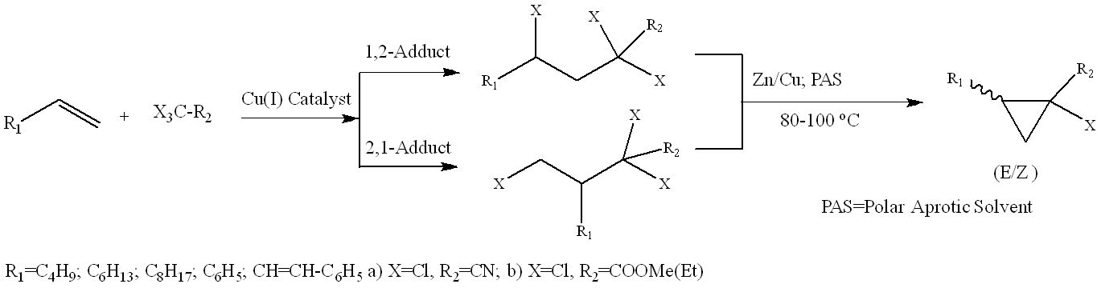
Figure 1. The general scheme of synthetic transformations
In current research we developed highly efficient catalytic system [Cu(I) Catalyst: 1) CuBr - 10 mol% to substrate, 2) secondary ammine, 3) catalytic co-ligand/solvent – DMSO․ Molar ratio1):2):3) = 1:1:7-10], reaction time: 1.5h, adducts yield: 95%.
In addition, we conducted a docking study of ethylene biosynthesis inhibitory activity for newly synthesized (E)-2-phenyl-1-chlorocyclopropane-1-carboxylic acid (1R,2S and 1S,2R isoforms) in comparison to commercially applicable methylcyclopropane and natural inhibitor pyrazinoic acid on ACO2(Arabidopsis thaliana) (Table 1).
Table 1. Docking results
Ligand | Methylcyclopropane | Pyrazinoic acid | 1R,2S | 1S,2R
Affinity | -3.1 | -5.3 | -6.0 | -6.2
Binding sites | Leu189  (Phe36, Ala251 / Leu198, Arg247, Ser249) | Leu189, Leu177, Arg247, Ser249, Lys161, His180, His237  (Leu198) | Leu189, Leu198, Ser249, Ser163, Tyr165, Val239, Lys161, Ala251, Asn219, Ile187, Phe253 His237 | Leu189, Leu198, Leu177, Ser249, Ser163, Tyr165, Val239, Lys161, Ala251, Ile187, Phe36, His237
Literature
1. Hormone Metabolism and Signaling in Plants. 1st Ed. / ed. Li J., Li C., Smith S. Beijing, CN: Academic Press, 2017.
2. Argueso C.T., Hansen M., Kieber J.J. Regulation of Ethylene Biosynthesis // J Plant Growth Regul. 2007. Vol. 26. P. 92–105.
3. Karapetyan H.A., Tamazyan R., Mikaelyan A.R., Raganyan N.P. X-Ray Investigation of (E)-2-phenyl-1-chlorocyclopropane-1-carboxylic Acid — A Convenient Synthon for Transamine Synthesis. 2004. Vol. 45(2). P. 352-255.

