Fabrication of hydrophobic surfaces of aluminum alloys by laser irradiation
Andrey Abramov¹, Vlad Samyshkin¹, Nazrullo Halimov¹, Samuel Essaka¹, Anton Osipov¹, Stella Kutrovskaya^{1,2,3}
1- Department of Physics and Applied Mathematics, Stoletov Vladimir State University, 600000 Gorkii street, Vladimir, Russia
2 - School of Science, Westlake University, 18 Shilongshan Road, Hangzhou 310024, China
3 - Institute of Natural Sciences, Westlake Institute for Advanced Study, 18 Shilongshan Road, Hangzhou 310024, China

Abstract — Laser modification of aluminum alloys with inclusions of B₄C microparticles is of significant interest due to a significant increase in strength and temperature characteristics of the obtained material. In the process of laser irradiation of a composite material with an aluminum matrix, it is possible to form cluster objects that change the density of alloying additives distribution on the surface. In this work, we propose the creation of hydrophobic surfaces with macrogeometry controlled by the laser beam trajectory, and microgeometry determined by the target surface modification processes during local laser heating
Keywords— laser modification, hydrophobic surface, contact angle
Surface wettability control has attracted increased research attention due to a wide range of applications, from domestic innovations, such as self-cleaning glass, to high-tech fields such as microfluidic control, corrosion resistance, fluid separation, and resistance reduction. Research into the creation and preparation of highly wettable surfaces has opened up the possibility of using them for fluid transport and smart sensor devices.
Aluminum alloys are used in various industries due to the unique combination of qualities: low density with high values of specific strength, corrosion resistance and thermal conductivity. In terms of strength and fluidity-to-density ratio, strong aluminum alloys surpass low-carbon and low-alloy steels and titanium and are inferior only to high-strength high-alloy steels and titanium alloys.
Laser texturing is a promising method for the fabrication of hydrophobic surfaces due to its potentially high fabrication speed, low waste, and one-step processing without the need for masks. the possibility of creating hydro- and superhydrophobic metal surfaces for real industrial applications using nanosecond fiber lasers is an urgent applied problem.
Here we develop a procedure for forming hydrophobic surfaces. Our surfaces are based on changing the topography of aluminum composites with the addition of boron carbide particles.
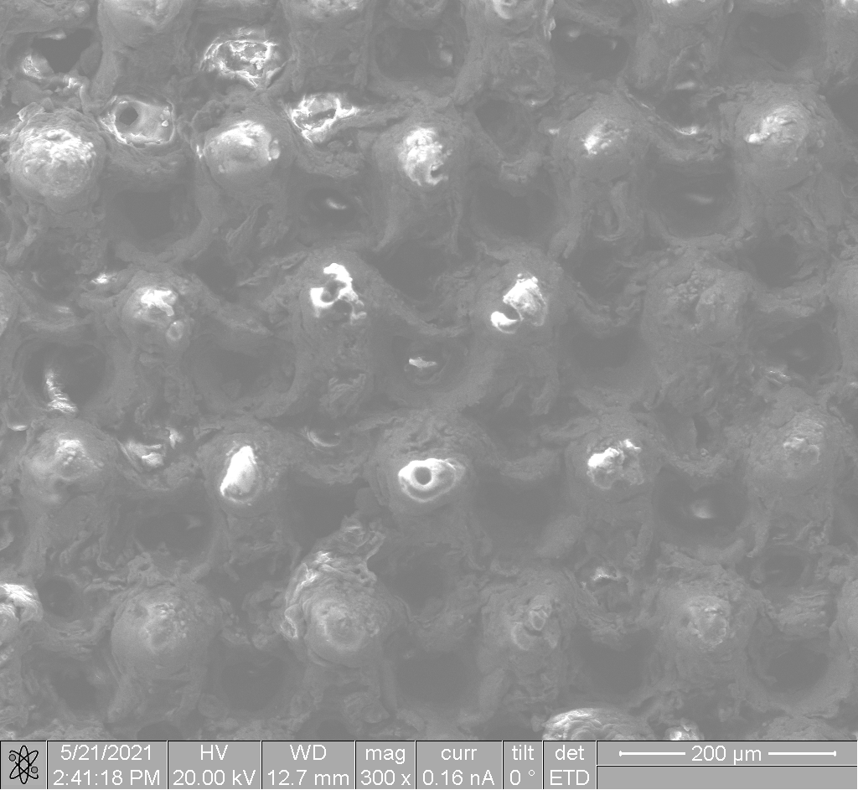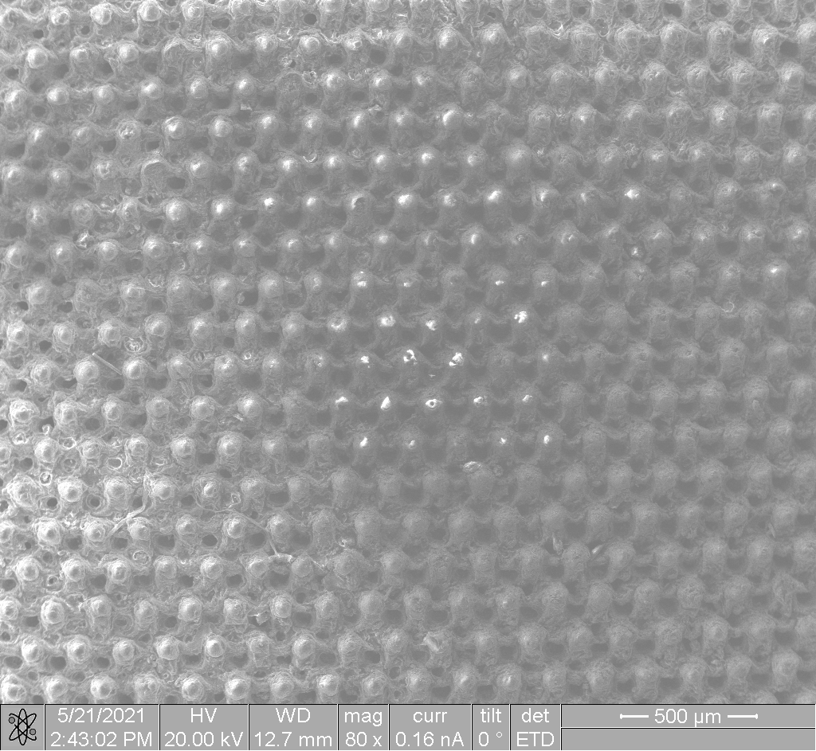
a) b)
Figure 1. SEM images of the sample surface after action of a laser beam moving on hexagonal trajectories
YAG:Nd laser source was used to texture a composite target surface. The typical parameters of laser action: the exposure time - 10; 10 ns - pulse duraction with repetition frequency of f = 100 kHz; the pulse power is about 10 W. During laser processing we have applied two options in laser track microgeometry as hexagonal and circular are. As a result the formation of different microstructures on a surface takes place.
As a result of the laser processing the formation of different microstructures on a surface takes place.
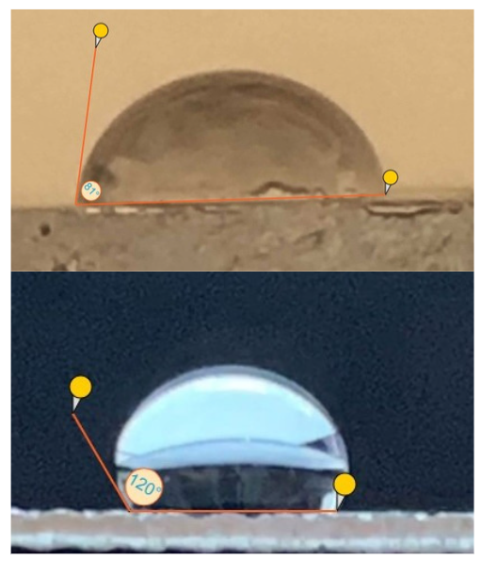
Figure 2. The optical images of the surface testing before laser field action on hydrophobic feature in time
Determination of the boundary wetting angle was carried out by the lying drop method. Before treatment, the edge wetting angle of the sample was 81°. For all treated samples an increase of the marginal wetting angle to values exceeding 90° was detected, i.e. hydrophobization took place after surface structuring by laser irradiation. The highest value of the marginal angle was 120°. Based on the results obtained, we can conclude that the above samples were more consistent with the Wenzel model, and the change in surface texture has a positive effect on the hydrophobic properties of the aluminum and boron carbide alloy.

Acknowledgment
This work is supported by RFBR grant 20-21-00038. A.O. acknowledges support from the Ministry of Science and Higher Education within the State assignment Vladimir State University, project No. 0635-2020-0013.

References
- Мillеs, S.; Vоisiаt, В.; Nitsсhkе, М.; Lаsаgni, А.F. Influеnсе оf rоughnеss асhiеvеd bу реriоdiс struсturеs оn thе wеttаbilitу оf аluminum using dirесt lаsеr writing аnd dirесt lаsеr intеrfеrеnсе раttеrning tесhnоlоgу. // J. Маtеr. Рrосеss. Тесhnоl., – 2019, Vоl. 270, Р. 142–151.
- Kucherik A., Samyshkin V., Prusov E., Osipov A., Panfilov A., Buharov D., Arakelian S., Skryabin I., Kavokin A. V., Kutrovskaya S., Formation of fractal dendrites by laser-induced melting of aluminum alloys. // Nanomaterials, - 2021, 11, 1043.

