Магнитооптические эффекты в диэлектрических наноструктурированных пленках феррита-граната
Воронов А.А.
студент
Московский государственный университет имени М.В.Ломоносова,
физический факультет, Москва, Россия
E-mail: voronapower@yandex.ru
In the paper we perform experimental investigation of the magneto-optical effects in 1D all-dielectric gratings made of perforated bismuth-substituted iron garnet film on gadolinium gallium garnet substrate.
Previously, for local enhancement of the field, metal gratings were used, in which surface plasmon-polaritons were excited using incident light. But gradually, all-dielectric gratings are gaining more and more interest. The main reason for this phenomenon is that in the metal there are inevitable losses in the visible and infrared spectral ranges [1]. These losses can be made much less if dielectrics are used. But in dielectric gratings, the surface plasmon-polariton will not be excited anymore. Instead, we select the parameters of the gratings in such a way that a waveguide mode could exist in it [2]. The process of excitation of the waveguide mode with the wave number is presented in Fig.1a. The excitation condition of the waveguide mode in the 1D structure is as follows:
Excitation of the waveguide mode is responsible for local field enhancement, see Fig. 1b. On the other hand, resonance conditions are sensitive to the transversal magnetiazation of the structure resulting in the multifold enhancement of the transversal magneto-optic Kerr effect (TMOKE). The results of TMOKE measurements on a 1D grating with p-polarized incident light are presented in Fig.1c. The magnitude of TMOKE in waveguide mode-supporting grating is up to 0.5% while the smooth film provide nearly 2 orders lower response.
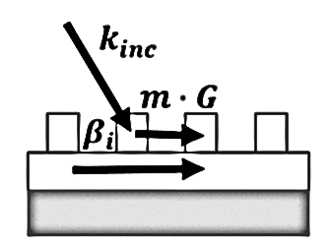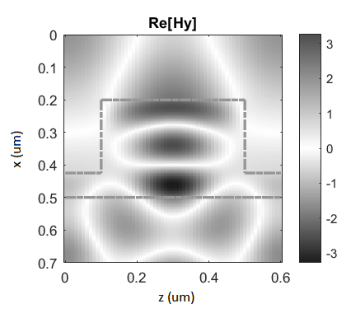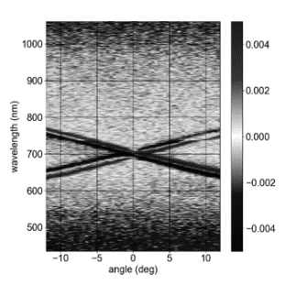
(a) (b) (c)
Fig.1: a - schematic representation of the excitation of the waveguide mode
b – local field enhancement
c – TMOKE measurements on a 1D grating with p-polarized incident light
Therefore, excitation of the waveguide modes in all-dielectric iron-garnet gratings results in the local field enhancement and significant increase of the TMOKE effect. Moreover, TMOKE resonances have high quality factors and narrow widths up to 5 nm which is a significant advantage compared to the plasmonic structures.
This work was supported by the RSF grant No. 18-72-00233.

Литература
- Gamet E., et al. Enhancement of magneto-optical effects by a single 1D all dielectric resonant grating // 2017 J. Phys. D: Appl. Phys. 50 495105.
- Maksymov I.S. Magneto-Plasmonics and Resonant Interaction of Light with Dynamic Magnetisation in Metallic and All-Magneto-Dielectric Nanostructures // Nanomaterials. 2015. No. 5. P. 577-613.

